Bahria University,

Karachi Campus



LAB EXPERIMENT NO.

**06**

LIST OF TASKS

|  |  |
| --- | --- |
| TASK NO | OBJECTIVE |
| 01 | Perform Visualizations on the csv file of titanic |

SUBMITTED ON:

09/11/2023

**LAB 07 DATA VISUALIZATIONS**

I**mporting the dataset using pandas read_csv**

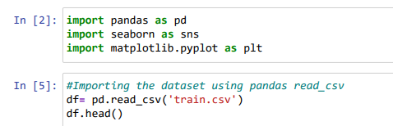

**Group By Survival**

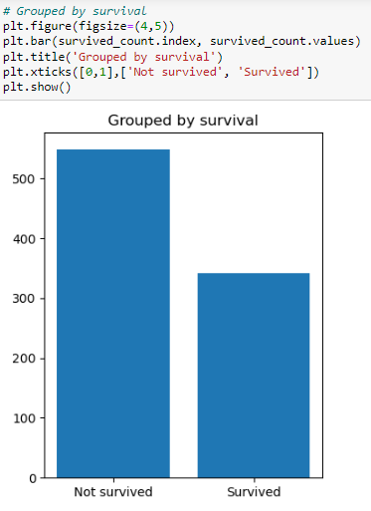

**Group the data frame by classes in the pclass column,and count the number.**

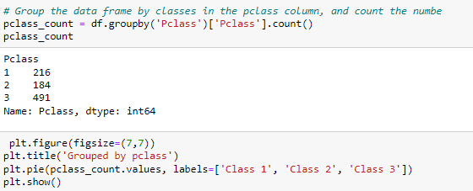

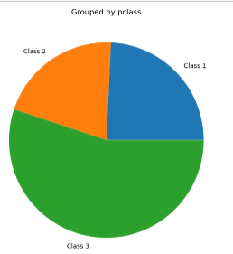

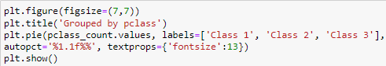

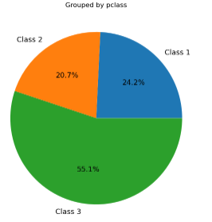

**Group the dataframe by classes in the gender column,and count the number.**

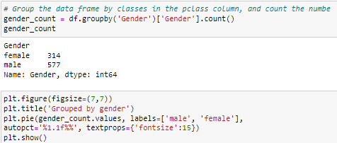

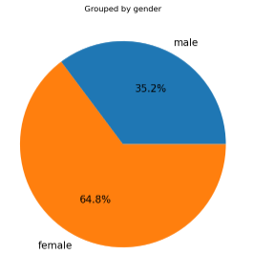

**Group the dataframe by classes in the embark column ,and count the number.**

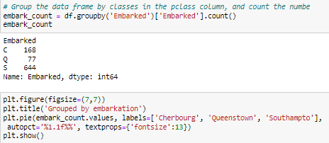

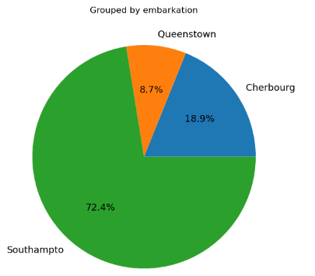

**Survival Number according to gender or sex ie Male and Females**

